Software Design Final Project

Michael Smith

Professor Nalubandhu

SWENG 837

4/28/24

# 

Problem Statement and Requirements

Business Requirements

Problem Statement

Functional Requirements

Actors List

Business Goals

Non-Functional Requirements

Performance Requirements

Security Requirements

Maintainability Requirements

Additional Non-Functional Requirements

System Design using Domain Modeling

UML Use Case Diagram

UML Domain Model

UML Class Diagram

UML Sequence Diagrams

System Sequence Diagram

Sequence Diagram: Password Reset

Sequence Diagram: MFA Setup

UML State Diagram

UML Activity Diagram

UML Component Diagram

UML Deployment Diagram

Design Patterns

Grasp

Controller

Low Coupling

High Cohesion

Solid

Single Responsibility Principle

GoF

Factory Method

Microservices

API Gateway

Database per Service

Circuit Breaker

# 

# Problem Statement and Requirements

## Business Requirements

### Problem Statement

As fraud and cybercrime become a staple of the modern digital landscape, ensuring the safety of user data during authentication has become critical.

### Functional Requirements

* User Registration:
  + User registration with personal details such as email and password
  + Implement strong password policies to enhance security.
* Password Hashing:
  + Employ modern cryptographic methods to hash passwords securely.
  + Ensure that passwords are never stored in plaintext.
* Login Process:
  + Provide a secure login mechanism that verifies hashed passwords.
  + Include measures to prevent brute force and dictionary attacks, such as rate limiting.
* Multi-Factor Authentication (MFA):
  + Support multi-factor authentication options, including SMS-based OTP, email verification, or authenticator apps.
  + Make MFA mandatory for accessing sensitive features.
* Session Management:
  + Manage user sessions securely with timeout policies and secure cookie attributes.
  + Provide a logout functionality that fully clears session data.
* Account Recovery:
  + Offer a secure account recovery process using email or SMS.
  + Include identity verification steps to prevent unauthorized account access.

### Actors List

|  |  |  |
| --- | --- | --- |
| **Type** | **Actor** | **Goal Description** |
| Primary | User | Access various aspects of user data to qualify user identification and security |
|  | System Administrator | Monitor and control system’s accounts, permissions, settings, and security. |
| Supporting | Cloud Storage | Cloud provider for data storage |
|  | Credential Management System | Authority to authenticate user credentials |
|  | MFA Solution | Providing Multi-factor Authentication Management |
| Offstage | External entities | Access user data to inform a variety of federal and state agencies decisions. |

### Business Goals

* Decrease company data breach incidents
* Simplify user workflow to secure company data
* Compatible with all mainstream devices

## Non-Functional Requirements

### Performance Requirements

* **Scalability**: The system must, without degrading performance, be able to handle users in excess of 1 million users concurrently.
* **Response Time**: Under normal system circumstances all authentication responses should not exceed 2 seconds.
* **Throughput**: System should be able to process authentications at a rate of 1000 transactions per second with no system performance degradation.

### Security Requirements

* **Authentication**: Employ methods for robust user verification, including such as password hashing and multi-factor authentication.
* **Authorization**: Employ system control policies to prevent users accessing restricted areas of the system.
* **Data Encryption**: Implement AES for data storage and TLS for data transmission in order to prevent data from being accessed without authorization.
* **Regular Security Audits**: Schedule regular security audits to identify potential data security risk vectors.

### Maintainability Requirements

* **Code Modularity**: System architecture should be modular for simpler maintainability.
* **Documentation**: Maintain up-to-date documentation of all pertinent aspects of the system, including codebase, user guidelines and API.
* **Testing Strategies**: Employ rigorous, automated testing protocols such as unit, integration and system tests.

### Additional Non-Functional Requirements

* **Usability**: Design a visually intuitive interface to minimize user dissatisfaction.
* **Accessibility**: Provide modern accessibility features for disabled users.
* **Reliability**: System target uptime: 99.9%.
* **Interoperability**: System should be able to communicate without translation to higher languages.
* **Internationalization**: Include regional and multilingual settings to support global users.
* **Compliance**: Adhere to all relevant legal and government regulatory requirements.

# System Design using Domain Modeling

## UML Use Case Diagram

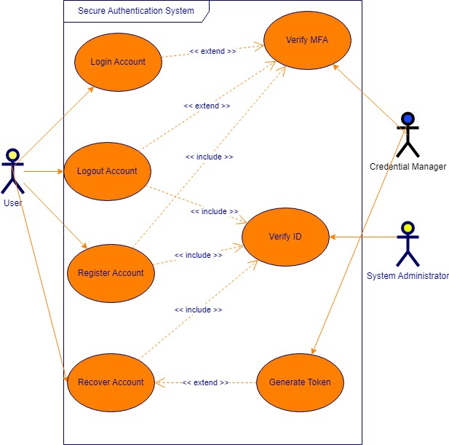

## UML Domain Model

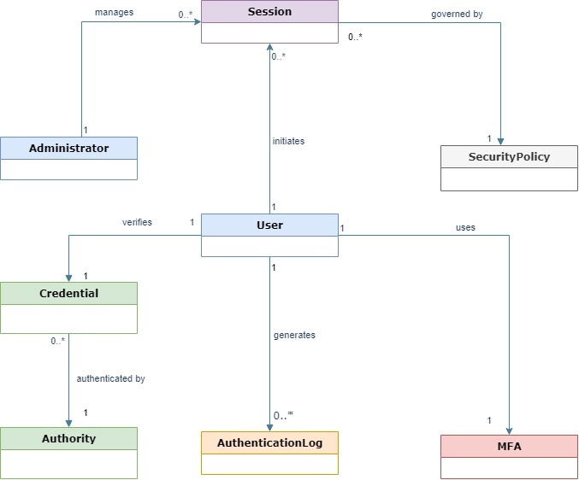

## UML Class Diagram

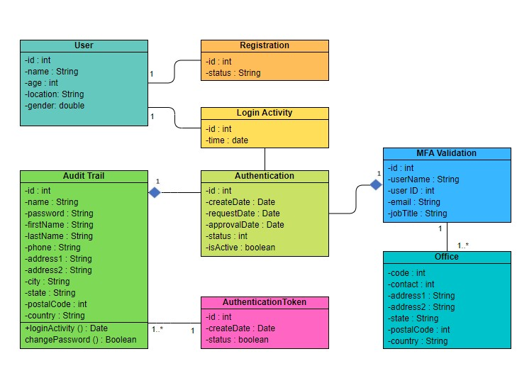

## UML Sequence Diagrams

### System Sequence Diagram

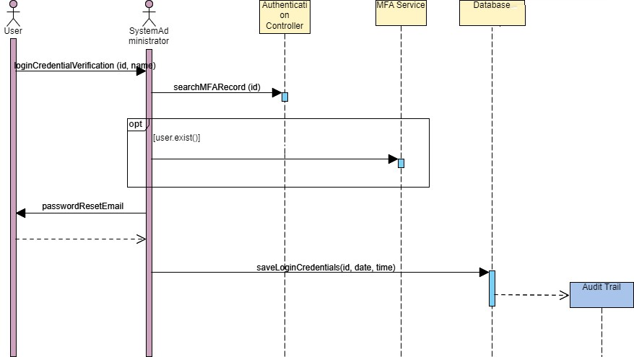

### 

### Sequence Diagram: Password Reset

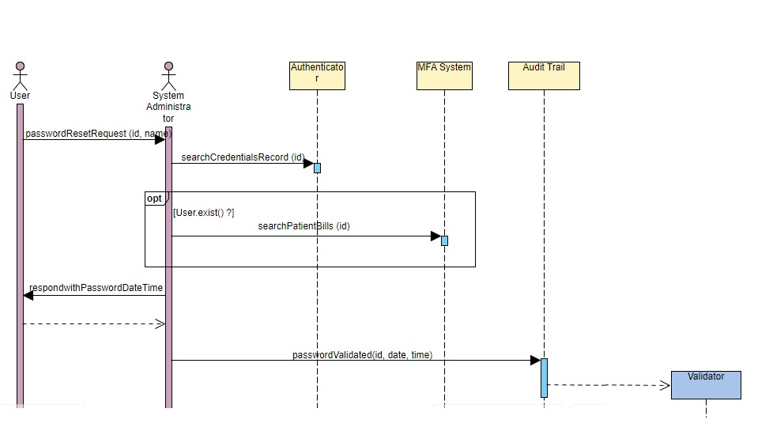

### 

### Sequence Diagram: MFA Setup

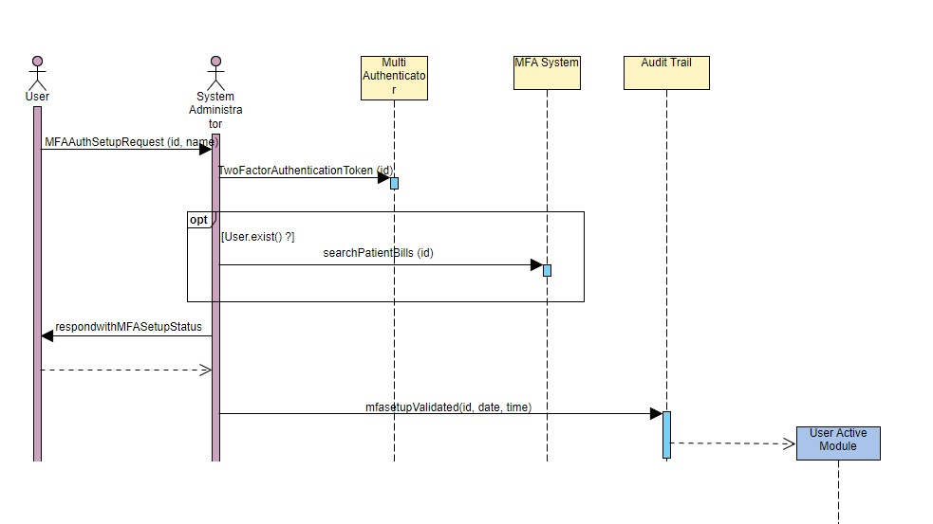

## UML State Diagram

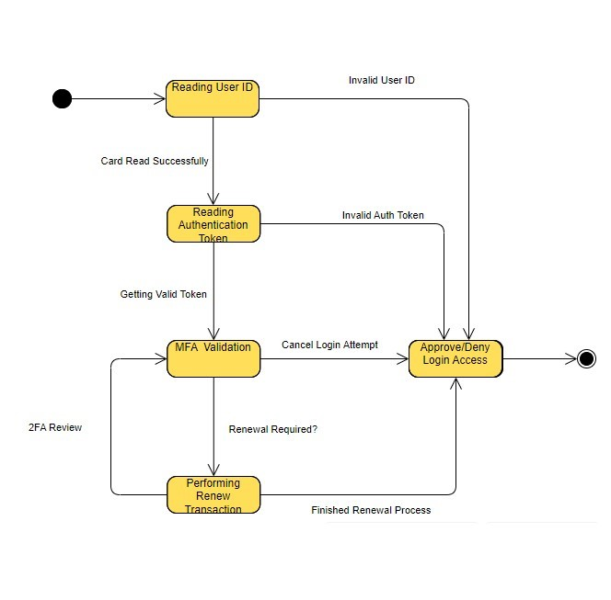

## UML Activity Diagram

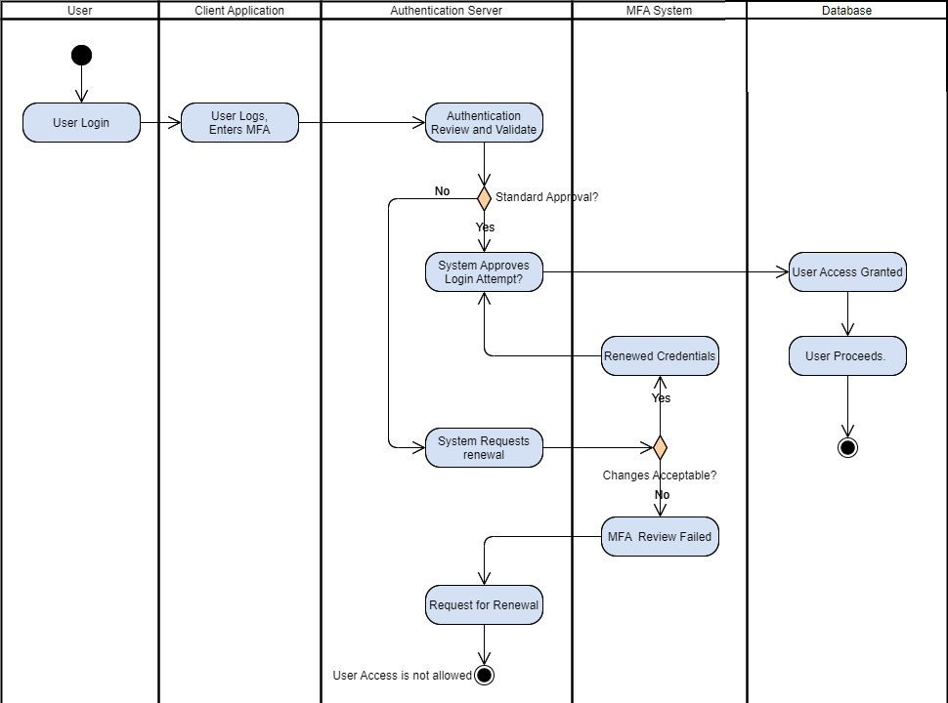

## UML Component Diagram

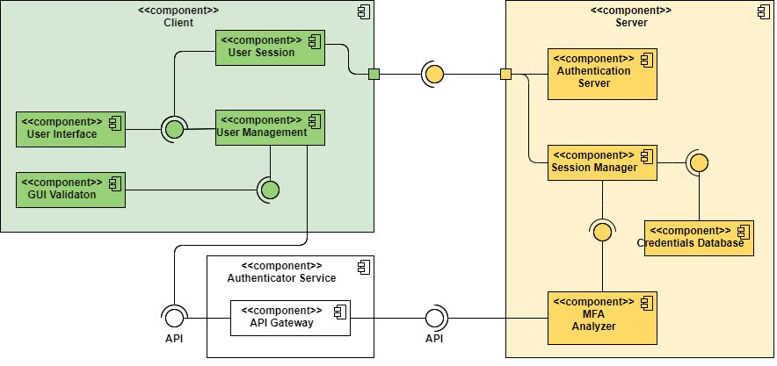

## UML Deployment Diagram

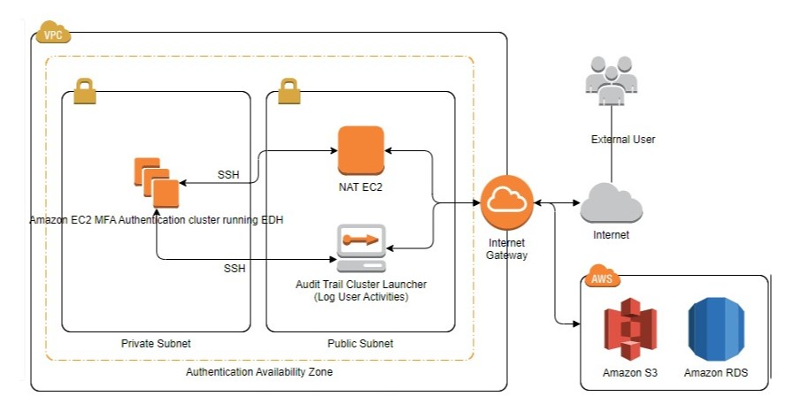

## Design Patterns

### Grasp

#### Controller

AuthenticationController is the intermediary between the UI and backend services, this was done in order to keep the system easy to maintain and scale.

#### Low Coupling

AuthenticationController also achieves lower coupling for essentially the same reason as above. This allows components to be altered or replaced with little impact on the system.

#### High Cohesion

Classes in the system are kept in narrow, well defined roles;this modularity, in addition to achieving the aforementioned results, also helps keep complexity to a minimum, reducing likelihood of errors.

### Solid

#### Single Responsibility Principle

Ensuring classes have only one reason to change helps prevent changes in one class causing unnecessary changes to another class.

### GoF

#### Factory Method

For creating objects without specifying their class, useful for MFA challenges.

### Microservices

#### API Gateway

The API Gateway acts as a single entry point for the client, efficiently streamlining authentication and authorization.

#### Database per Service

The systems microservices each have their own separate database. This assists with service decoupling and data security.

#### Circuit Breaker

By employing a proxy to monitor service responses, cascading failures across multiple services can be cut off like a “circuit breaker.”